

**MBF.TestAutomation Guide**

|  |  |
| --- | --- |
| **Version no.** | 9.0 |
| **Date** | June 30, 2010 |
| **Author** | Bhaskar S |
| **Approved by** |  |
| **Client name** | Microsoft |

Revision History

|  |  |  |  |  |  |  |  |
| --- | --- | --- | --- | --- | --- | --- | --- |
| **Sl no.** | **Version no.** | **Date** | **Nature of change** | **Affected pages** | **Authored by** | **Reviewed by** | **Approved by** |
| **1** | **1.0** | **26 May 2009** | **Initial Draft** |  | **Bhaskar S** |  |  |
| **2** | **2.0** | **14 July 2009** | **Update for M3** |  | **Bhaskar S** | **Vivek Kumar** |  |
| **3** | **3.0** | **04 Sep 2009** | **Update for M4** |  | **Bhaskar S** | **Vivek Kumar** |  |
| **4** | **4.0** | **03 Nov 2009** | **Update for Beta 1** |  | **Bhaskar S** | **Vivek Kumar** |  |
| **5** | **5.0** | **16 Dec 2009** | **Update for M6** |  | **Bhaskar S** |  |  |
| **6** | **6.0** | **10 Feb 2010** | **Update for Beta 2** |  | **Bhaskar S** |  |  |
| **7** | **7.0** | **29 March 2009** | **Update for M8** |  | **Bhaskar S** |  |  |
| **8** | **8.0** | **13 May 2010** | **Update for M9** |  | **Bhaskar S** |  |  |
| **9** | **9.0** | **30 June 2010** | **Update for V1** |  | **Bhaskar S** |  |  |

Table of Contents

**Automation Code Path** 5

**Test Automation Code Structure** 5

MBF.Net Object Model 5

Sequence Test cases 5

Encoding & Translation test cases 5

Translation Test cases 5

Encoding Test cases 5

Parsers and Formatters which support different file formats 5

FastA Test cases 5

GenBank Test cases 5

Gff Test cases 5

FastQ Test cases 5

Phylogenetic Test cases 6

Snp Test cases 6

Bed Test cases 6

SAM Test cases 6

BAM Test cases 6

ClustalW parser Test cases 6

Nexus parser Test cases 6

Phylip parser Test cases 6

FileVirtualQualitativeSequenceProvider Test cases 6

FileVirtualSequenceProvider Test cases 6

PAMSAM Assembly Algorithms 6

PAMSAM Test cases 6

MBF Registration 7

Registration Test cases 7

MBF Matrix 7

Matrix Test cases 7

Alignment and Assembly Algorithms 7

Alignment Test cases 7

Assembly Test cases 7

Web-Service Clients for executing Blast queries 7

NCBI Blast Web Service Test cases 7

EBI Blast Web Service Test cases 7

Azure Blast Web Service Test cases 7

BioHPC Web Service Test cases 7

ClustalW Web Service Interface Implementation Test cases 7

**Dependencies** 8

**Test cases Automated** 8

**Overview of Test cases Automated** 8

**How to Run the Automation?** 8

Pre-condition for Microsoft Internal 9

Pre-condition for External Partners 9

Run 9

**How to Validate the Pass/Fail status of Test cases?** 9

**How to update the Sequences and Files in the xml?** 10

**How to Validate the Code Coverage? (Microsoft Internal Only)** 10

Pre-requisite for running the Code Coverage tool Magellan 10

Steps for Running Magellan tool 10

Appendix A: Review and Sign-off 12

Appendix B: Glossary/ Definitions 13

**Automation Code Path**

Automation Code for MBF core components is present under the path“*\MBF\MBF.TestAutomation”*

**Test Automation Code Structure**

­­Automation code is structured on the same lines as the MBF development code mentioned below are the paths where the test automation suite is located.

## MBF.Net Object Model

### Sequence Test cases

Present under the location “\MBF\MBF.TestAutomation”. This folder contains all the BVT’s, P1’s and P2’s for Derived, Segmented, Sparse, Sequence Range, Virtual, Virtual Data, Qualitative, Compound and Sequences test cases.

## Encoding & Translation test cases

### Translation Test cases

Present under the location “\MBF\MBF.TestAutomation\Algorithms\Translation”. This folder contains all the BVT’s and P1’s for Translation i.e., Codons, Protein translation, Complementation and Transcription.

### Encoding Test cases

Present under the location “\MBF\MBF.TestAutomation\IO\Encoding”. This folder contains all the BVT’s and P1’s for Encoding i.e., Encoding map, Sequence Decoder, Sequence Encoder, IupacNAEncoding, Ncbi2NAEncoding, Ncbi4NAEncoding, NcbiEAAEncoding and NcbiStdAAEncoding.

## Parsers and Formatters which support different file formats

### FastA Test cases

Present under the location “\MBF\MBF.TestAutomation\IO\Fasta”. This folder contains all the BVT’s and P1’s for Fasta Parsers & Formatters.

### GenBank Test cases

Present under the location “\MBF\MBF.TestAutomation\IO\Genbank”. This folder contains all the BVT’s and P1’s for GenBank Parsers & Formatters.

### Gff Test cases

Present under the location “\MBF\MBF.TestAutomation\IO\GFF”. This folder contains all the BVT’s and P1’s for Gff Parsers & Formatters.

### FastQ Test cases

Present under the location “\MBF\MBF.TestAutomation\IO\Fastq”. This folder contains all the BVT’s and P1’s for Fastq Parsers & Formatters.

### Phylogenetic Test cases

Present under the location “\MBF\MBF.TestAutomation\IO\Newick”. This folder contains all the BVT’s and P1’s for Newick Parsers & Formatters.

### Snp Test cases

Present under the location “\MBF\MBF.TestAutomation\IO”. This folder contains all the BVT’s and P1’s for Snp Parsers.

### Bed Test cases

Present under the location “\MBF\MBF.TestAutomation\IO”. This folder contains all the BVT’s and P1’s for Bed Parsers & Formatters.

### SAM Test cases

Present under the location “\MBF\MBF.TestAutomation\IO”. This folder contains all the BVT’s and P1’s for Sam Parsers.

### BAM Test cases

Present under the location “\MBF\MBF.TestAutomation\IO”. This folder contains all the BVT’s and P1’s for Bam Parsers & Formatters.

### ClustalW parser Test cases

Present under the location “\MBF\MBF.TestAutomation\IO”. This folder contains all the BVT’s and P1’s for ClustalW Parsers.

### Nexus parser Test cases

Present under the location “\MBF\MBF.TestAutomation\IO”. This folder contains all the BVT’s and P1’s for Nexus Parsers.

### Phylip parser Test cases

Present under the location “\MBF\MBF.TestAutomation\IO”. This folder contains all the BVT’s and P1’s for Phylip Parsers.

### FileVirtualQualitativeSequenceProvider Test cases

Present under the location “\MBF\MBF.TestAutomation\IO”. This folder contains all the BVT’s and P1’s for FileVirtualQualitativeSequenceProvider class.

### FileVirtualSequenceProvider Test cases

Present under the location “\MBF\MBF.TestAutomation\IO”. This folder contains all the BVT’s and P1’s for FileVirtualSequenceProvider class.

## PAMSAM Assembly Algorithms

### PAMSAM Test cases

Present under the location “\MBF\MBF.TestAutomation\PAMSAM”. This folder contains all the BVT’s and P1’s for PAMSAM assembly algorithm.

## MBF Registration

### Registration Test cases

Present under the location “\MBF\MBF.TestAutomation”. This folder contains all the BVT’s and P1’s for MBF.Registration test cases.

## MBF Matrix

### Matrix Test cases

Present under the location “\MBF\MBF.TestAutomation\Matrix”. This folder contains all the BVT’s for MBF.Matrix test cases.

## Alignment and Assembly Algorithms

### Alignment Test cases

Present under the location “\MBF\MBF.TestAutomation\Algorithms\Alignment”. This folder contains all the BVT’s, P1’s and P2’s for Alignment i.e., NeedlemanWunsch algorithm, SmithWaterman algorithm, PairwiseOverlap algorithm, MUMmer algorithm, NUCmer algorithm and Sequence alignment.

### Assembly Test cases

Present under the location “\MBF\MBF.TestAutomation\Algorithms\Assembly”. This folder contains all the BVT’s and P1’s for Assemblies i.e., Simple sequence assembler, PaDeNA and Simple consensus method.

## Web-Service Clients for executing Blast queries

### NCBI Blast Web Service Test cases

Present under the location “\MBF\MBF.TestAutomation\Web\Blast”. This folder contains all the BVT’s and P1’s for NCBI Blast web service test cases.

### EBI Blast Web Service Test cases

Present under the location “\MBF\MBF.TestAutomation\Web\EbiBlast”. This folder contains all the BVT’s and P1’s for EBI Blast web service test cases.

### Azure Blast Web Service Test cases

Present under the location “\MBF\MBF.TestAutomation\Web\AzureBlast”. This folder contains all the BVT’s and P1’s for Azure Blast web service test cases.

### BioHPC Web Service Test cases

Present under the location “\MBF\MBF.TestAutomation\Web\BioHPC”. This folder contains all the BVT’s and P1’s for BioHPC web service test cases.

### ClustalW Web Service Interface Implementation Test cases

Present under the location “\MBF\MBF.TestAutomation\Web\ClustalW”. This folder contains all the BVT’s and P1’s for ClustalW web service interface implementation test cases.

**Dependencies**

The binaries on which the automation is dependent are

* “\MBF\MBF\bin\Debug\MBF.dll”
* Download nunit from the website ‘http://nunit.org/index.php?p=download’ and refer that binary
* .Net 4.0

**Test cases Automated**

3388 test cases are totally automated, the spread sheet embedded below shows the test cases which are automated are marked as “Automated” as per the PS query below. This 3388 also includes the Unit test cases which are already automated as part of Unit testing.



**Overview of Test cases Automated**

The below matrix shows the number of test cases automated out of 6223 test cases which was identified as part of M2, M3, M4, M5, Beta 1, M6, M7, Beta 2, M8, M9 and V1.

|  |  |  |
| --- | --- | --- |
| **Priority** | **Number of Test cases** | **PS Query** |
| BVT | 1044 |  |
| P1 | 1667 |  |
| P2 | 677 |  |

**How to Run the Automation?**

The pre-condition and the Steps to run the automation is as below.

## Pre-condition for Microsoft Internal

* NUnit and .NET Framework 4.0 needs to be installed on the machine where the automation is run.
* NUnit.exe can be found in the location “\Public\ext\nunit\bin\net-2.0\nunit-x86.exe” and should be installed.

## Pre-condition for External Partners

* NUnit and .NET Framework 4.0 needs to be installed on the machine where the automation is run.
* Download nunit from the website ‘http://nunit.org/index.php?p=download’ and install the same.

## Run

* Launch *“NUnit 5.3.1”* icon from the location where the NUnit is installed and Navigate to “*File->Open Project…*” and browse for the file *“\Debug\MBF.TestAutomation.dll”* which was copied in the previous step and run by pressing F5.

**How to Validate the Pass/Fail status of Test cases?**

On Running the Automation, the NUnit GUI interface would display the Total Number of Test cases executed, Total Test cases which was run successfully, Total test cases failed, Total test cases ignored, Total test cases skipped and the time taken to run all the test cases, as per the screen shot below.

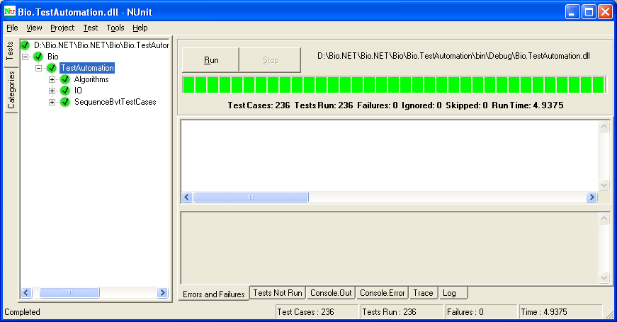

The NUnit GUI interface would provide the log information, to find the same, Navigate to the Tab “*Log*”.

Also additional log information can be found in the location *“\Debug\MBF.automation.log”.*

Ideally the Failures as per the screen shot above should show as 0.

If any test cases failed, Navigate to the Tab “*Errors and Failures*” in NUnit GUI interface which would show the test cases failed and the reason for the same.

**How to update the Sequences and Files in the xml?**

The Config file for running the automation is Present under the location “\MBF\MBF.TestAutomation\TestUtils\TestsConfig.xml”. Below example shows one of the nodes used to run one of the BVT test cases, where we update the information of FastA file used for in the test case, the expected sequence and other details related to the Test case which is required for validation of a specific sequence present in the FastA file.

<!-- This node contains the Fasta file information for running the BVT test cases. -->

<SimpleFasta>

<FilePath>TestUtils\Simple_Fasta_Protein.fasta</FilePath>

<ExpectedSequence>IFYEPVEILGYDNKSSLVL</ExpectedSequence>

<ExpectedSequenceCount>435</ExpectedSequenceCount>

<AlphabetName>Protein</AlphabetName>

<SequenceID>gi|186972391|gb|ACC99454.1| maturase K [Scaphosepalum rapax]</SequenceID>

<FormatString>>gi|186972391|gb|ACC99454.1| maturase K [Scaphosepalum rapax]IFYEPVEILGYDNKSSL</FormatString>

<ExpectedSequenceAfterAdd>IFYEPVEILGYDNKSSLVL</ExpectedSequenceAfterAdd>

</SimpleFasta>

This file can be updated to change the sequence or the file from which the Sequence is to be read and accordingly other values in the node needs to be updated for validation and the file should be updated added if any in the location “\MBF\MBF.TestAutomation\TestUtils” and the project needs to be built and then follow the steps as said in section “How to Run Automation?”. Similar to the TestsConfig.xml, MUMmerTestsConfig.xml, FastQTestsConfig.xml, NUCmerTestsConfig.xml, QualitativeTestsConfig.xml, MSAConfig.xml , GFFTestsConfig.xml and other config xml’s can be updated.

**How to Validate the Code Coverage? (Microsoft Internal Only)**

Below are the steps which needs to be performed for validating the code coverage for MBF.dll.

## Pre-requisite for running the Code Coverage tool Magellan

* Install Magellan Code coverage tool.
* Sql Server Database needs to be created for saving the code coverage information.

## Steps for Running Magellan tool

* Open the command prompt and run the commands below.
* *bbcover /importonly  /i "\MBF\MBF\bin\Debug\MBF.dll" /db "Data Source=<SQL SERVER>;Database=<SQL DATABASE NAME>;User ID=<SQL USER ID>;Password=<SQL USER PASSWORD>"*
* *bbcover /i "\MBF\MBF\bin\Debug\MBF.dll" /o "\MBF\MBF\bin\Debug\MBF_instr.dll"*
* Delete the MBF.dll and rename MBF_instr.dll to MBF.dll.
* Remove the strong key for the dll *"\MBF\MBF\bin\Debug\MBF.dll”* by executing the command “*sn –R ”\MBF\MBF\bin\Debug\MBF.dll“ “\MBF\MBF\bio.snk””*.
* Build the Automation project.
* Continue executing the below commands
* *Start covermon*
* *covercmd /reset*
* RUN the Automation following the steps said in section “How to Run Automation?”
* Execute the command “*covercmd /save /db " Data Source=<SQL SERVER>;Database=<SQL DATABASE NAME>;User ID=<SQL USER ID>;Password=<SQL USER PASSWORD>*" in command prompt, this step saves the Code coverage information in the Database specified.
* Validate the same by navigating to the “Start->All Programs->Microsoft Magellan Toolset->Microsoft Sleuth”
* Create a New Project giving a Project name.
* Right click on the Newly created project and click on “Add Database…”.
* Provide the Sql server information and click on Ok.
* Expand the Project as per the screen shot below and validate the Code coverage percentage.

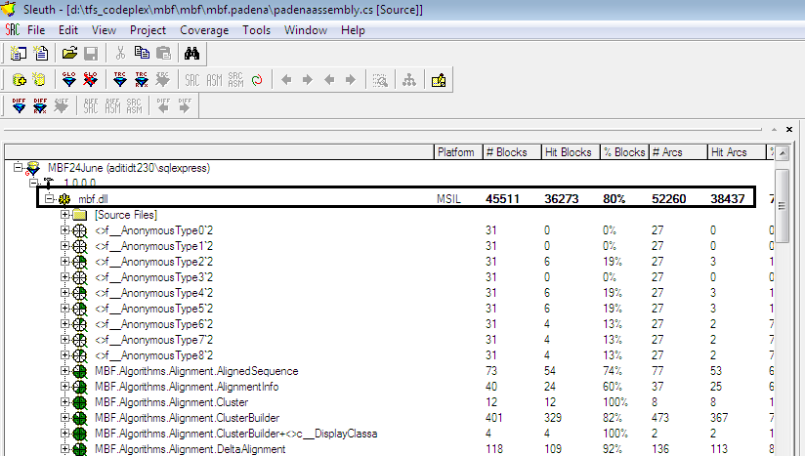

Review and Sign-off

[Below is a list of the project team members and required reviewers and as distinguished from approvers.]

|  |  |  |  |
| --- | --- | --- | --- |
| Person | Role | Contact | Reviewed Date |
|  |  |  |  |
|  |  |  |  |
|  |  |  |  |

Glossary/ Definitions

[Below is a list of common terms and their definitions that are used throughout this document:]

|  |  |
| --- | --- |
| Term | Definition |
| BVT | Build Verification Test |
| PS | Product Studio |